*Lab 3: Inductors and Time Dependent Signals*

Physics 411

John Waczak

11/09/2016

Lab Partner: Kyle Tafoya

**Introduction/Background**

Lab 3 studied the characteristics of the component known as the inductor. In its simplest form conductor is simply a loop of wire through which current is passed. Under a direct current, an inductor has very little resistance, however, when a time dependent current is passed through the component, the magnetic properties of the coil induce an emf in the opposite direction according to Faraday’s law:

$$ε=-\frac{dΦ}{dt}$$

Where epsilon is the induced emf and phi is the magnetic flux. We can then say that the Voltage drop across an inductor is given by the equation:

$$V_{l}=L\frac{dI}{dt}$$

Where L is the ‘inductance’ of the inductor – a measure of how much the inductor opposes changes in current. Thus we may consider the inductor to act as a potential source that will increase the current decreases and will oppose the current if it increases.

Similar to the RC circuit, an RL circuit can be described by a time constant $τ$ which in the case of inductors is equal to $\frac{L}{R}$. The time dependence for resistor – inductor circuit voltage can then be written as: $V_{l}=V_{s}e^{\frac{-t}{τ}}$. When considering the RL configuration in the frequency domain we can also deduce the following equation by Fourier analysis:

$\left|\frac{V_{out}}{V_{in}}\right|=\frac{ω/{ω_{c}}}{\sqrt{1+ω/{ω_{c}}}}$ where $ω_{c}$ is the cut-off frequency (breakpoint frequency) equivalent to $\frac{1}{τ}$. For the LR configuration, the equation becomes: $\left|\frac{V_{out}}{V_{in}}\right|=\frac{1}{\sqrt{1+ω/{ω_{c}}}}$.

Lab three consisted of 2 experiments which will be described in detail in the following lab report. The first experiment, marked number 2 on the lab outline, analyzed the time dependence of the RL circuit by determining the time constant through the use of the oscilloscope. Experiment 2, marked number 3 on the lab outline analyzed the frequency response of both configurations in order to determine the cut-off frequency empirically. This value was then compared to the theoretical definition.

**Theory/Circuit Diagrams/ Experimental Procedure**

2. *Time-dependent analysis of RL circuits*

The circuit shown below in figure 1 was constructed in order to test the time dependence of the RL circuit. 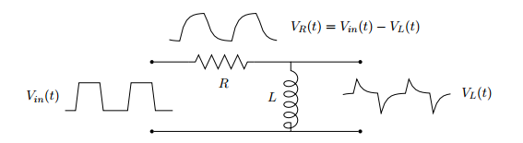

Figure : RL circuit – testing the time dependence

Initially, the values of R and L were chosen to be 196.2Ω and 18.5mH giving a time constant $τ$ = 0.00009. When looking through the scope though, this produced a very large reflection that could be seen on the output waveform in the oscilloscope. We surmised that this effect was due in part to the fact that our resistance was so small in comparison to the effective reactance of the inductor. Thus we decided to increase the resistance to 1.09kΩ and reduce the inductance to 10mH. This gives instead a time constant $τ$ = 0.000009 which produced a much clearer output waveform at 1kHz. The DC resistance of the inductor was measured to be 21.3Ω. Using the TTL sync on the function generator, one charge and discharge cycle was captured across the inductor for an input square wave.

After measuring tau, the frequency on the input voltage was varied from 0 to 1 MHz in order to determine the range over which the behavior of the circuit was similar to that at the original 1kHz. Finally, the square-wave input was changed to both a triangle and sine wave in order to further observe the behavior of the circuit.

Part B of experiment 1 repeated the above procedure for the reversed LR configuration measuring the output voltage across the resistor instead. The LR configuration is shown below in figure 2.

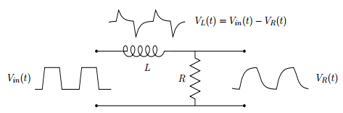

Figure : The LR circuit configuration

3. *Frequency response of both configurations*

The second experiment in Lab 3 analyzed the frequency response for both the RL and LR circuits pictured above in figures 1 and 2. A sine wave was applied to both configuration and the frequency was varied from 0 to 1 MHz. Both the amplitude of Vin and Vout were measured as well as the difference in time between the two signals (as a reflection of the phase difference).

For each configuration, the theoretical and experimental curves were plotted using a Bode plot which measures 20log|Vout/Vin| vs log(f). From these plots, the cut-off frequency can be measured at the -3dB mark equivalent to the value of R/L in terms of theory. After plotting these graphs, the nature of each configuration can be determined… i.e. whether or not the circuit acts as a low pass filter, high pass filter, or neither.

**Results/Data/Graphs**

2. *Time-dependent analysis of RL circuits*

As mentioned previously the value for the time constant in the circuit for experiment 1 was 0.000009. Graph 1 and 2 below show the graphs capturing the charging and discharging cycles of the resistor-inductor circuit for a 1kHz square wave input. The graphs were used in order to test if the theoretical time dependence is the same as what we measured empirically.

Graph RL - discharging

Graph RL – charging

From the above graphs the time constants can be determined by looking at the $\frac{1}{e}$ (discharging) and $1- \frac{1}{e}$ (charging) times. These correspond to when the time is equal to tau such that Vout for charging is 63.2% of Vsource and Vout is equal to 36.8% of Vsource for discharging. These values for the measured data are 0.000004 and 0.0000088. Both values are to the same order of magnitude as the theoretical value however, the charging value is approximately half of the theory value as opposed to the discharging value which is 97.8% of the theory. This is likely due to capacitance from the oscilloscope probe affecting the behavior of the circuit.

Graphs 3 and 4 below show the same data taken for the LR configuration:

Graph : LR - Charging

Graph : LR – discharging

The measured time constants are 0.0000084 for charging and 0.000005 for discharging. Again the values are to the same order of magnitude as the theoretical however for the LR configuration it is the discharging circuit that showed a value nearly 50% from the theoretical. Clearly there is some persistent effect which is likely still from the scope probe however I think the reason why this shows on the discharging side could be chalked up to the behavior of the circuit changing as the configuration was switched.

Part d of experiment 1 we found that for the RL configuration (high pass), the behavior was consistent for high frequencies above 100kHz (with an observed phase shift near 750 kHz and above). Below around 20kHz, the graph began to flatten out and approach a constant value of 0 volts. Similarly, for the LR configuration (low pass) the charging/discharging began to turn saw-tooth around 100 kHz and was nearly 0 Volts for frequencies nearing 750kHz to 1MHz. This reflects the behavior of each circuit as a high pass and low pass filter.

Finally, the last part of the first experiment asked us to apply sine and triangle waves to the input. Graphs 5, 6 below show the input and output signals for the LR configuration. Unfortunately, my file was corrupted for the RL configuration so I could not include a comparison for this configuration.

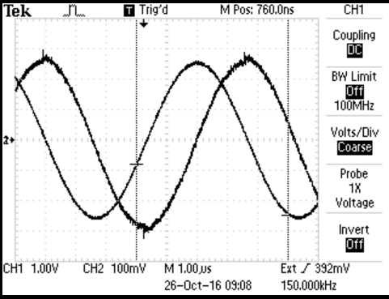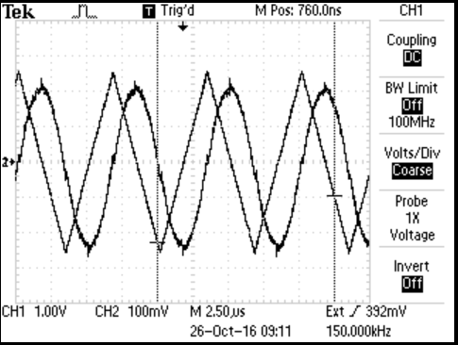

Graph : Triangle wave input

Graph sinewave input

As you can see above, the LR configuration (Low pass) appears to act an integrator for middle range frequencies like that shown above. In graph 5, the linear portions of the triangle wave are integrated to parabolas. Similarly, the sinewave input is integrated to a cosine output (as evidenced by quarter period phase shift). For the RL configuration, I would expect to see it perform as a differentiator for middle to high frequencies. This would look like a square wave for the Triangle input and another sinusoid for the sinewave input.

3. *Frequency response of both configurations*

As previously mentioned, the second experiment had us measure the difference between the input and output voltages as the input frequency was varied from 0 to roughly 1 MHz. Graphs 7 and 8 below show the Bode plots for the RL and LR configurations which measure 20log(|Vout/Vin|) vs log(f). These graphs are designed to show the characteristic “cut-off” frequency at the -3 dB mark. For each situation, the experimental data was plotted alongside the theoretical plot obtained by calculating the cut-off frequency and transmission function from the equations described in the introduction.

Graph : RL - Bode Plot

Graph : LR - Bode Plot

As the graphs clearly show, the theory plot for each configuration matches almost perfectly to the experimental data. Thus we can say that the value for the cut-off frequency is equivalent to the theoretical value of $1/{2πτ}≈17.68 kHz$ for both cases. The plots also reflect the behavior of the RL configuration as a high pass filter and the behavior of the LR configuration as the Low pass filter.

**Conclusions**

Lab 3 demonstrated the characteristics of the passive component called an inductor. It’s time dependence and frequency response were both tested in a manner similar to that of Lab 2’s analysis of the capacitor. In general, it appears that while the capacitor “stores charge”, the inductor acts as if it “stores current”. This current then opposes any change in the signal applied at the source.

Two basic configurations were analyzed: the RL and LR circuits. Each was found to behave as a filter although the characteristics were reversed to those of the CR and RC circuits with the RL acting as a high pass filter and the LR acting as a low pass.

The first experiment found that the time dependence was measured to be the same to the order of magnitude of the theoretical prediction. It appears that the circuits using the inductor were affected more by the characteristics of the oscilloscope probe (be that capacitance or inductance) than those from lab 2 that used capacitors.

The second experiment affirmed the theoretical predictions that the RL configuration acts as a high pass filter and the LR configuration acts as a low pass. The theoretical cut-off frequency was confirmed empirically at the -3dB point by comparing the theoretical plots to those obtained using the oscilloscope. For future experimentation, I would like to examine the qualities

Sources:

1. <http://physics.oregonstate.edu/~mcintyre/COURSES/ph411/ph411labwriteup.pdf>
2. <http://schematics.com>